Environmental Education
EE4. Do you offer courses that teach specifically on climate science and/or environmental sustainability?
1-The College of Computer Science and Information Technology witnesses National Plantation Day activities.
Under the supervision of the Dean of the College, Professor Dr. Saif Ali Abdul Redha Al-Saeedi.
This step comes as an opportunity for national participation in preserving nature and encouraging interest in planting trees and plants in Iraq to enhance wildlife as well as provide a healthy and clean environment.
It is noteworthy that March 12 of each year has been considered a day for national afforestation to encourage people to plant trees and palm trees, take care of them, and protect vegetation. This day also aims to increase the area of green spaces, restore and protect natural forests, while giving more attention to restoring cultivated areas and planting new green spaces.
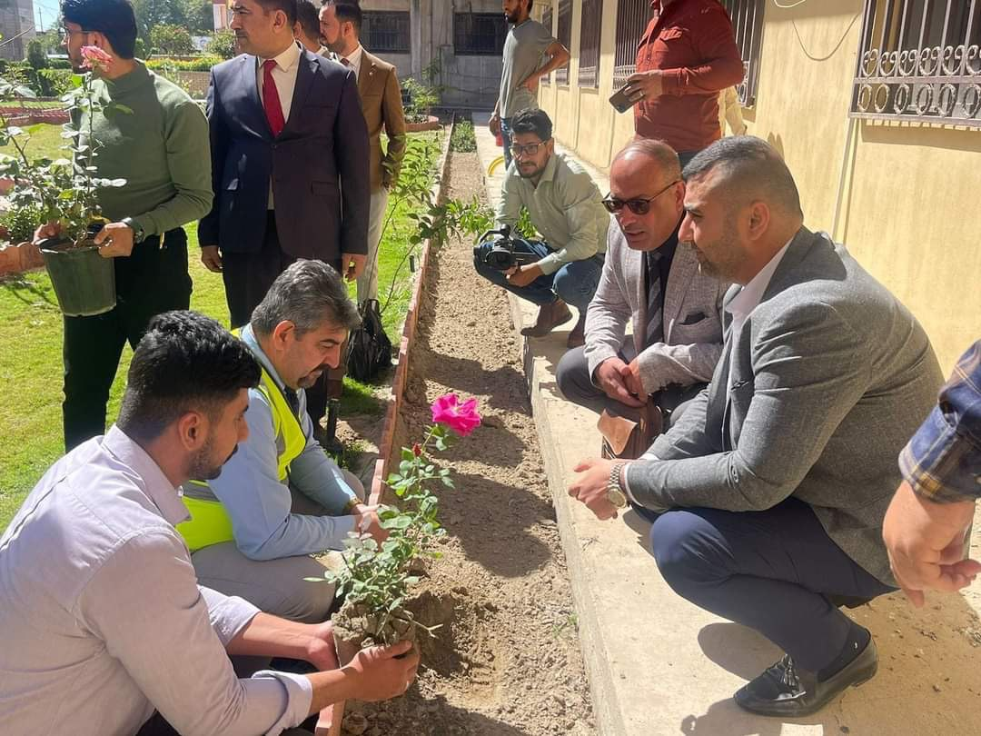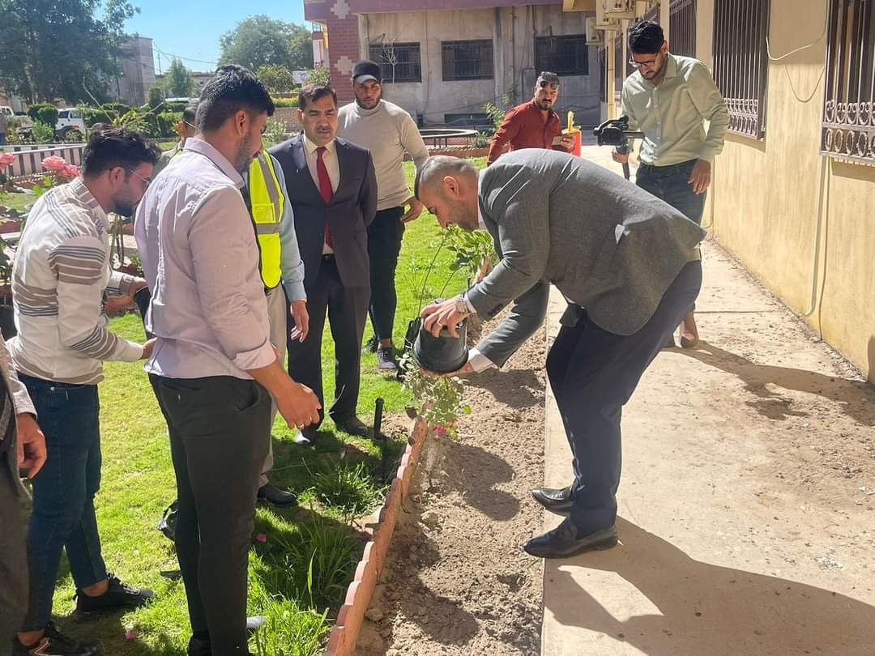

2- The College of Computer Science and Information Technology at Wasit University organized a scientific symposium entitled (Applications of artificial intelligence in the field of climate change).
The symposium aims to use technology, specifically artificial intelligence, as an innovative means to combat these challenges. Employing artificial intelligence in the field of climate change opens new horizons for data analysis, weather forecasting, and developing sustainability solutions.
The symposium discussed one of the main applications of artificial intelligence in this field: analyzing big data related to climate and the environment, and then using the results to guide policies and make strategic decisions. Artificial intelligence can also be used to develop accurate prediction models of climate change and its long-term impacts.
He touched on the use of artificial intelligence in developing technologies to reduce carbon emissions, such as improving energy efficiency and improving waste management. Artificial intelligence can also be used to analyze agricultural data to improve crop cultivation and manage water resources more effectively.
In conclusion, these uses demonstrate the efficiency of artificial intelligence technologies in supporting efforts to combat climate change and achieving a balance between economic development and environmental sustainability. These technologies require comprehensive integration and cooperation to achieve a greater positive impact in building a more sustainable future.
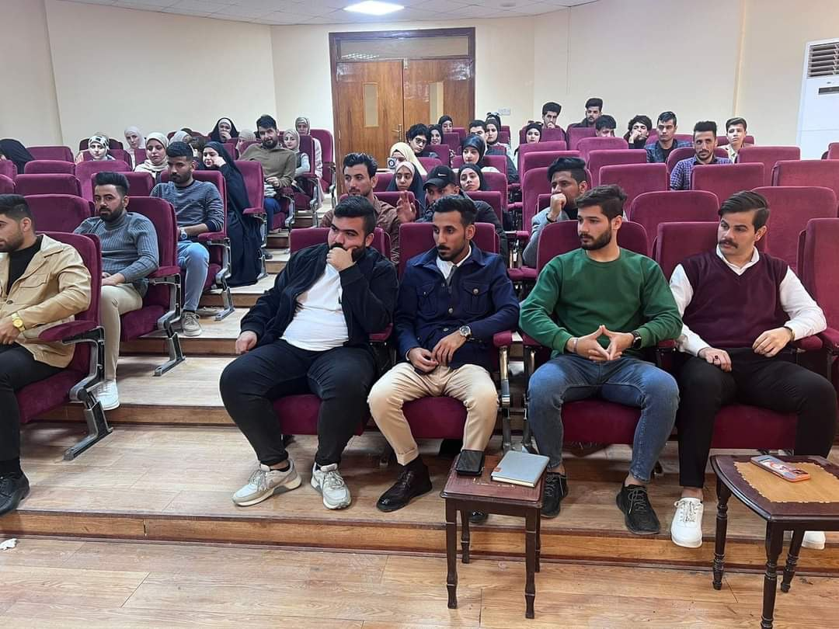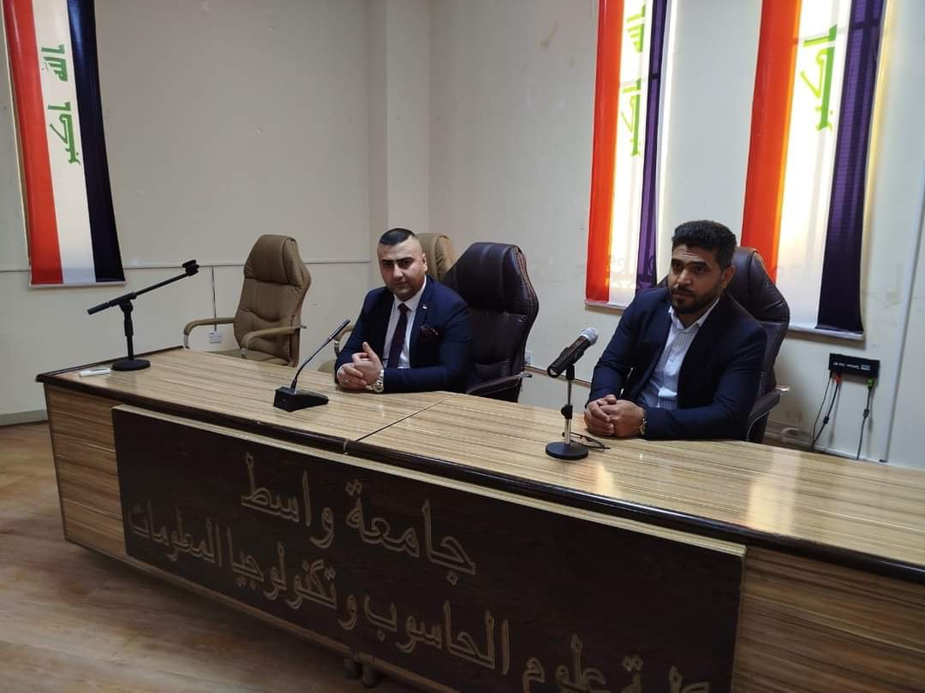
3. The College of Computer Science and Information Technology organizes a scientific symposium on the contributions of sustainable development in the academic, educational and pedagogical fields.
Within the activities of Sustainability Week, the College of Computer and Information Technology organized the title (Contributions of Sustainable Development in the Academic Field).
The symposium aims to provide meaningful and enhanced lectures and development sessions to qualify and develop the capabilities and energies of professors and students, in order to achieve qualitative thinking in adopting standard sustainable development goals in students’ projects, programs and curricula, especially graduation projects to achieve creative and innovative thinking.The symposium touched on a group of purposeful, applied scientific information and details, in which professors and students participated in a manner of purposeful discussion and dialogue, as the information was distinguished by its keeping pace with the projects, objectives, and programs of the university and college, and a development goal was achieved, which is to improve the outputs and develop the inputs to pay attention to the ethics of environmental upbringing, since the basic goal of sustainable development is to achieve Optimal investment of available natural resources for the current generation and future generations.
The symposium also emphasized the role of sustainable development in maintaining a safe environment for creativity, innovation and excellence, because of its real role in creating a contributing and qualitative creative atmosphere that encourages and supports individual ideas and ambitions. The Dean of the College participated in presenting qualitative ideas about the items, ideas and themes of sustainable development, especially programs. The projects that the college is currently planning include employing and investing students’ ideas in digitization, technology, and modern techniques, to transform them into purposeful programs and projects that serve service and production institutions,
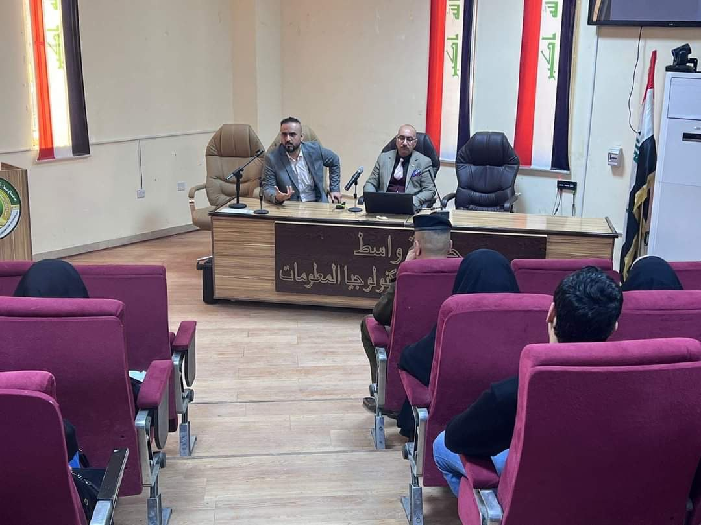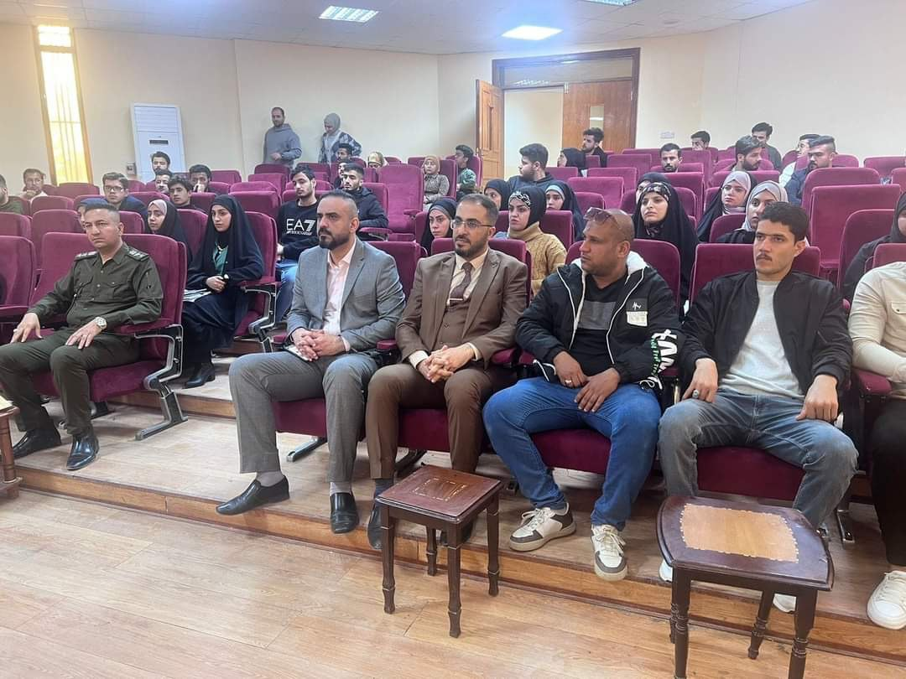

4- The College of Computer Science and Information Technology organizes a scientific symposium on
‘Climate change and natural resource sustainability.’
The College of Computer Science and Information Technology organized a scientific symposium entitled (Climate change and natural resource sustainability). Within the framework of the sustainable development program in Iraqi universities. The symposium touched on two axes. The first axis discussed climate change and sustainable development. The second axis. International efforts to sustain natural resources. The symposium recommended strengthening the role of civil society organizations for the sustainability of natural resources, strengthening policies and strategies based on scientific knowledge to protect the environment, and strong and effective coordination between the government and private sectors to address the challenges of climate change.
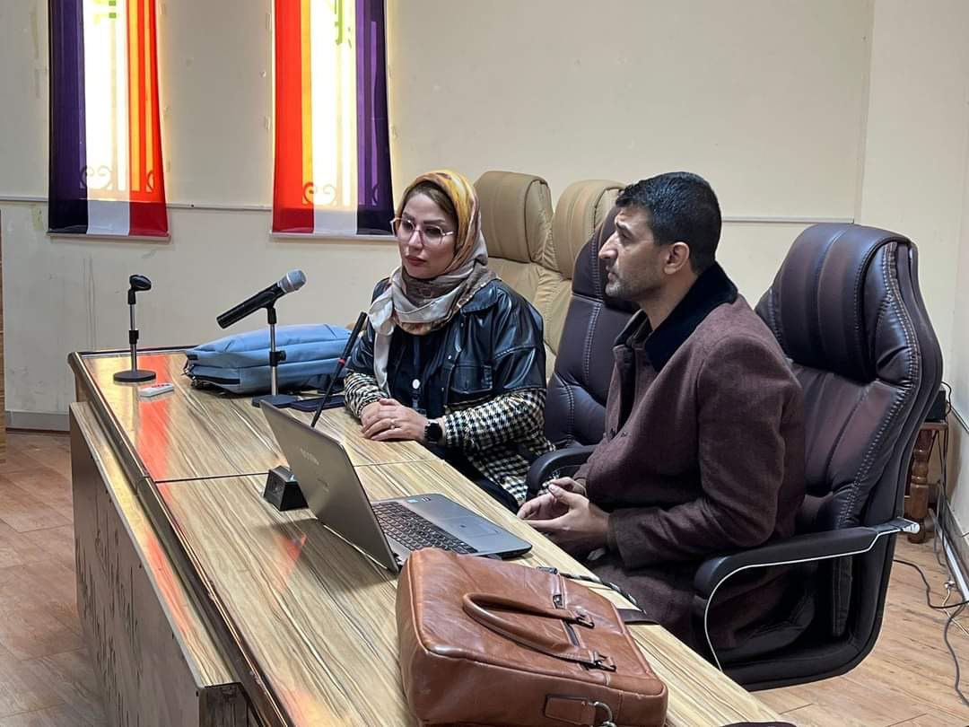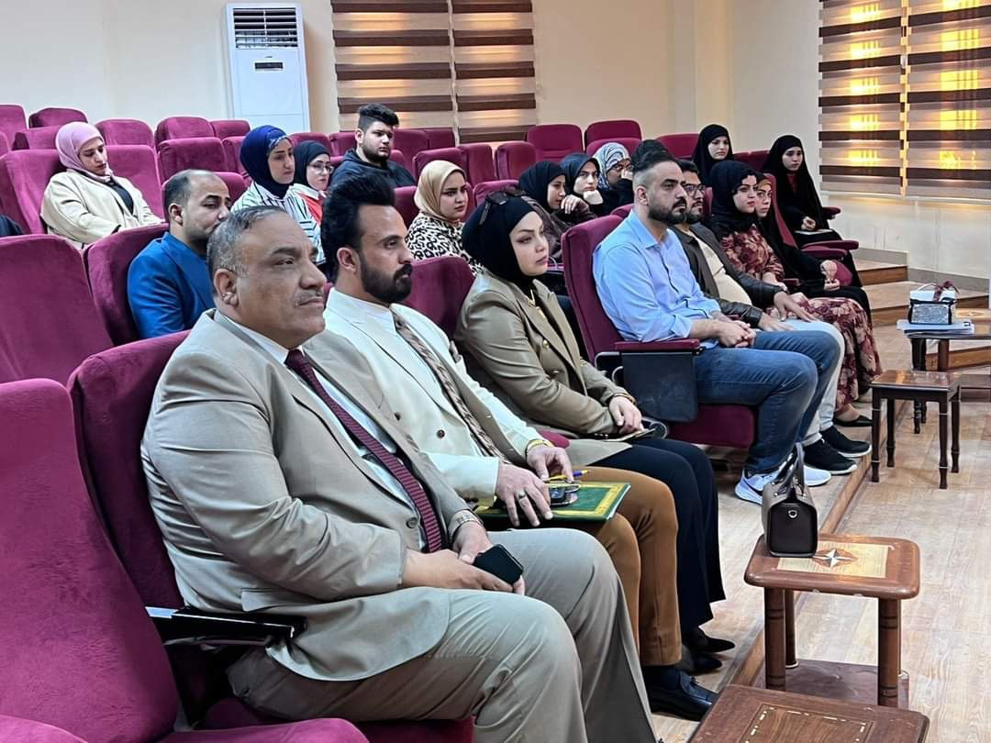

5- Organizes a scientific symposium on using technological innovation to improve health care and enhance public health in modern ways. The symposium aims to use technology to enhance health awareness, encourage healthy behaviors among people, and develop fitness applications and smart nutrition platforms that provide personal advice and guidance to individuals to improve their healthy lifestyle. The symposium highlighted the use of technology in providing remote health care, which facilitates access to medical services for people in remote areas or that lack adequate health infrastructure. This reduces the barriers that individuals may face in obtaining necessary medical care and contributes to enhancing overall public health. The symposium concluded that by using technology innovation in sustainable ways, we can revolutionize healthcare and enhance public health in the long term, making societies more resilient to health challenges and achieving better levels of healthcare for all.
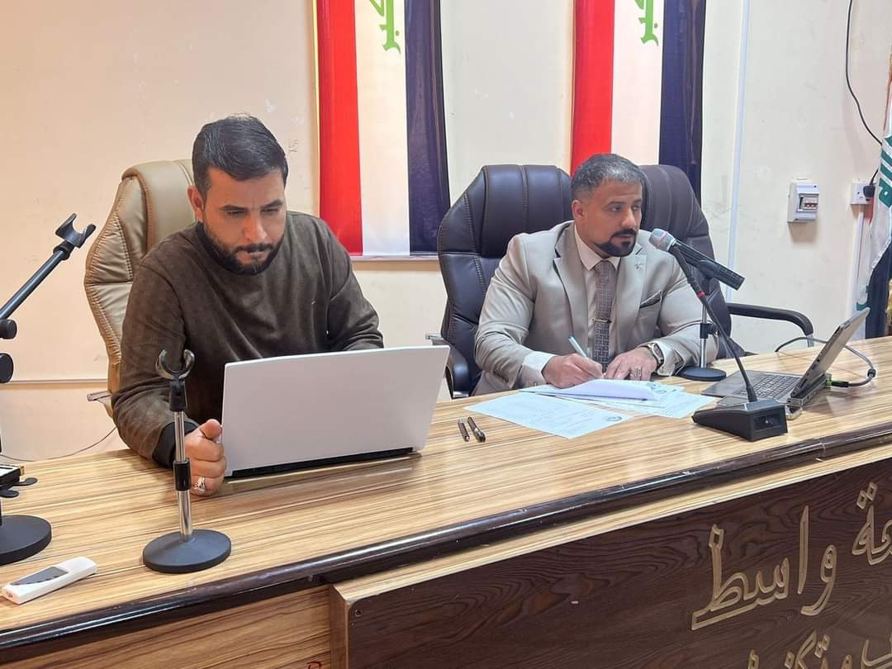

The Women's Empowerment Unit at the College of Computer Science and Information Technology, in cooperation with the Continuing Education Center, held a seminar entitled (Women's Economic Empowerment in Iraq)
In this seminar, the role of women in facing challenges, creating hope and a prosperous life was emphasized.
The seminar dealt with explaining the concept of women's economic empowerment and its importance in achieving balance in employment opportunities between the sexes and achieving economic growth, and also explained how to achieve this through several points:
- -Increasing educational opportunities
- - Providing programs that facilitate women's participation in the labor market
- -Supporting women entrepreneurs
- - Providing a safe and suitable work environment for women
The seminar aims to introduce women to the most important laws that govern their field of work, introduce them to the available fields of work, encourage them to establish their own projects, enhance the environment and all resources to support women and empower them economically and socially.

